

**E-Cloth Store**

**By**

**Fahad-Ibna Mahmud**

**ID: 20141201024**

**January, 2019**

**Department of Computer Science & Engineering**

**Bangabandhu Sheikh Mujibur Rahman Science and Technology University**

**E-Cloth Store**

**Fahad-Ibna Mahmud**

**ID: 20141201024**

**Department of Computer Science & Engineering**

**Bangabandhu Sheikh Mujibur Rahman Science and Technology University**

**E-Cloth Store**

(This project is submitted in the partial fulfillment of the requirement for the degree of Bachelor of Science in Computer Science & Engineering)

By

**Fahad-Ibna Mahmud**

**ID: 20141201024**

Supervised by

**Md. Nesarul Hoque**

**Assistant Professor**

Department of Computer Science & Engineering

Bangabandhu Sheikh Mujibur Rahman Science and Technology University

The project titled “**E-Cloth Store**” submitted by Student ID: 20141201024 Session: 2014-2015 has been accepted as satisfactory in partial fulfillment of the requirement for the degree of Bachelor of Science in Computer Science and Engineering in Bangabandhu Sheikh Mujibur Rahman Science and Technology University.

**BOARD OF EXAMINERS**

1. Md. Nesarul Houqe Supervisor

Assistant Professor

Department of Computer Science & Engineering,

Bangabandhu Sheikh Mujibur Rahman Science and Technology University.

2 External Member

3 Member

**STATEMENT OF ORIGINITY**

It is hereby declared that the contains of this project is original and any part it has not been submitted elsewhere for the award if any degree or diploma.

---------------------------------- --------------------------------

Signature of the Candidate Signature of the Supervisor

Date: Date:

**TABLE OF CONTENTS**

|  |  |  |  |
| --- | --- | --- | --- |
| **Acknowledgement** | |  | **VII** |
| **Abstract** | |  | **VIII** |
|  |  | |  |
| **Chapter 1** | **Introduction & Overview** | | **1** |
| 1.1 | Problem Overview | | 1 |
| 1.2 | Background | | 1 |
| 1.3 | Aims and objective | | 2 |
|  |  | |  |
| **Chapter 2** | **Related Work** | | **3** |
|  |  | |  |
| **Chapter 3** | **Project Design** | | **6** |
| 3.1 | Description | | 6 |
| 3.2 | Web Pages details | | 6 |
| 3.3 | Data Model | | 7 |
| 3.3.1 | Entity Relationship Diagram | | 7 |
| 3.3.2 | Database Design | | 9 |
| 3.4 | Process Model | | 13 |
| 3.4.1 | Data Flow Diagram (DFD | | 14 |
| 3.4.2 | Use Case Diagram | | 16 |
| 3.4.3 | User Interface Design | | 16 |
|  |  | |  |
| **Chapter 4** | **Implementation Details** | | **19** |
| 4.1 | Organization side | | 19 |
| 4.1.1 | Create Username & Password | | 19 |
| 4.1.2 | Delete items | | 19 |
| 4.1.3 | Modify items | | 20 |
| 4.2 | Customer side | | 20 |
| 4.2.1 | Categories are selected | | 20 |
| 4.2.2 | Buy Items | | 20 |
| 4.2.3 | View Cart | | 20 |
| 4.2.4 | Change Quantity | | 21 |
| 4.2.5 | Remove Items | | 21 |
| 4.3 | Hardware Interface | | 21 |
| 4.4 | Software Interface | | 21 |
| 4.5 | Security | | 21 |
|  |  | |  |
| **Chapter 5** | **Test Plan** | | **22** |
| 5.1 | Introduction | | 22 |
| 5.2 | Importance of testing | | 22 |
| 5.3 | Test Plan Strategies | | 22 |
| 5.3.1 | Unit Testing | | 23 |
| 5.3.2 | Integration testing | | 23 |
|  |  | |  |
| **Chapter 6** | **Limitation and Discussion** | | **24** |
| 6.1 | Limitation | | 24 |
| 6.2 | Discussion | | 24 |
|  |  | |  |
| **Chapter 7** | **Conclusion and Future Scope** | | **25** |
| 7.1 | Conclusion | | 25 |
| 7.2 | Future Work | | 25 |
|  |  | |  |
| **References** |  | | **26** |

**LIST OF FIGURES**

|  |  |  |
| --- | --- | --- |
| Figure-2.1 | eBay online shopping | 4 |
| Figure-2.2 | Daraz online shopping | 4 |
| Figure-2.3 | Ajkerdeal online shopping | 5 |
| Figure-3.1 | Entity Relationship Diagram | 8 |
| Figure-3.2 | User_Info Table from Database | 10 |
| Figure-3.3 | Order Table from Database | 12 |
| Figure-3.4 | Product from Database | 13 |
| Figure-3.5 | Data Flow Diagram | 14 |
| Figure-3.6 | Cart DFD | 15 |
| Figure-3.7 | Customer Authentication Context DFD | 15 |
| Figure-3.8 | Use Case Diagram | 16 |
| Figure-3.9 | Home Page | 17 |
| Figure-3.10 | Customer SignUp Form | 17 |
| Figure-3.11 | Add Product | 18 |
| Figure-3.12 | Edit/Delete Product | 18 |

**LIST OF TABLE**

|  |  |  |
| --- | --- | --- |
| Table-3.1 | User_info Table | 10 |
| Table-3.2 | Order Table | 11 |
| Table-3.3 | Product Table | 12 |

**Acknowledgment**

I am highly grateful to my project supervisor Mr. Md. Nesarul Hoque sir who provided me with an opportunity to work under his kind supervision and supported my idea to make this website.

**Fahad-Ibna Mahmud**

**January, 2019**

**Abstract**

Nowadays people are highly depend on online for buying or goods .The purpose of this website is that any person can buy their selected cloth from online at home. I create this website for those who love to buy specific cloth via online. E-Cloth Store is a virtual store on the Internet. The selected items may be collected in a shopping cart. At checkout time, the items in the shopping cart will be presented as an order. At that time, more information will be needed to complete the transaction. Usually, the customer will be asked to fill or select a billing address, a shipping address, a shipping option, and payment information such as Bkash. Online shopping is a form of electronic commerce which allows consumers to directly buy goods or services from a seller over the Internet using a web browser. Consumers find a product of interest by visiting the website of the retailer directly or by searching among alternative vendors using a shopping search engine, which displays the same product's availability and pricing at different e-retailers.

**Chapter 1: Introduction**

The objective of this project is to develop a general purpose e-commerce store where any cloth (such as T-shirt, Shirt, jeans, Trouser, Three Quarter and Shorts) can be bought by customer. However, for implementation can be bought from the comfort of home through the Internet purpose where customers can browse the catalog and select products of interest. E-Cloth Store is a virtual store on the Internet The selected items may be collected in a shopping cart. At checkout time, the items in the shopping cart will be presented as an order. At that time, more information will be needed to complete the transaction. Usually, the customer will be asked to fill or select a billing address, a shipping address, a shipping option, and payment information such as Bkash. Online shopping is a form of electronic commerce which allows consumers to directly buy goods or services from a seller over the Internet using a web browser. Consumers find a product of interest by visiting the website of the retailer directly or by searching among alternative vendors using a shopping search engine, which displays the same product's availability and pricing at different e-retailers. In this online based cloth store enables the customer to browse the firm's range of information about the products and services, view photos or images of the products, along with product price.

**1.1 Problem Overview**

The objective of the project is to make a website to help the online buyer who want to buy cloth from online store via internet by bkash or cash on delivery. This Website containing the way of make shopping easier.

**1.2 Background**

Now most of the people of our country use a internet. There are still exists such website but maximum of them are time consuming or less secure. Due to as usual method of shopping management we had to face a lot of difficulties like the information system. All the information gathering at a glance was too difficult and almost impossible. Considering this we decided to handle this problem by using web based cloth store. And finally with a great effort we executed a web based cloth store.

**1.3 Aims and objective**

* To provide some amount information of various type of cloth
* To make shopping more efficient and added attraction for potential customers.
* Control panel for making billing process as white list or black list for saving taxes by the seller for internal process.
* To provide Saving time in finding particular product and their price making billing process faster.
* To provide eliminating manual searching for the products which will be stock.
* To provide Saving time in finding particular product and their price making billing process faster Easy process of adding and deleting products entry.

**Chapter 2: Related Works**

Online shopping management system project will be used for various purposes under online shop For example - it will be used at the billing counter, searching of products in requested amount as per user requirements and configuration demands. Tracking of orders from the purchasers, delivery status for particular products, helpline numbers details and address within current city and in nearest city for particular manufacturers

**Amazon.com [1]**

Founded in 1995, Amazon is the largest online retailer in the world. It became a public company in 1997 and expanded sales from just books to software, computer hardware, electronics, apparel, furniture, food, and toys. Amazon also offers data storage and cloud services that allow companies to run applications from Amazon's infrastructure. In 2007, Amazon expanded its array of products introducing the Kindle e-reader[1].

**eBay [2]**

Founded in 1995, eBay is the world's largest online marketplace. It also offers online commerce platforms, and online payment solutions (it owns PayPal) to individuals and businesses in the United States and internationally. In 2010, the total worth of goods sold on eBay was $62 billion The company went public in 1998 [2].In **figure 2.1** shows eBay online shopping.

**Daraz [3]**

Daraz is a South Asian online retailer founded in 2012 by a German venture capital company, Rocket Internet. Daraz Group operates its e-commerce sites in Pakistan, Bangladesh, Nepal, Sri Lanka, and Myanmar. In May 2018, Daraz Group was acquired by the Chinese e-commerce company Alibaba Group. In **figure 2.2** shows daraz online shopping.

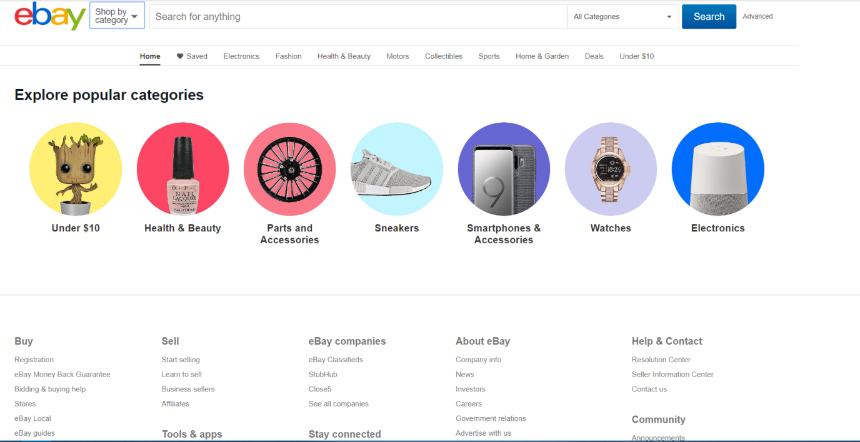

**Figure 2.1: eBay online shopping**

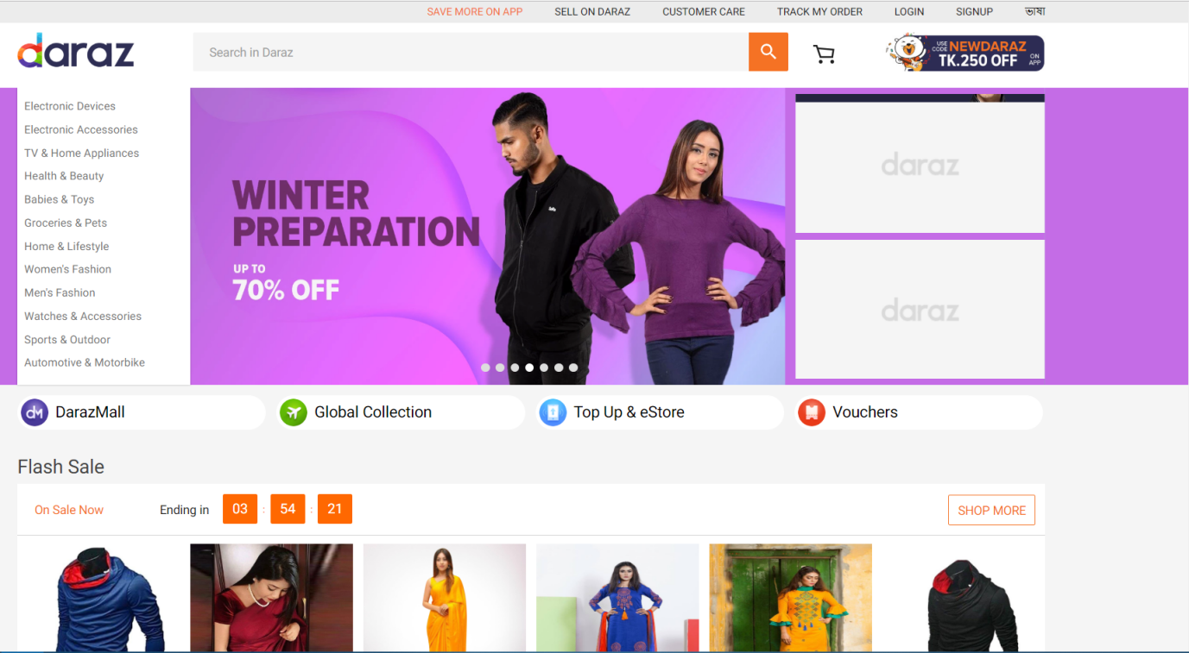

**Figure 2.2: Daraz online shopping**

**Ajkerdeal.com [4]**

AjkerDeal.com is the largest online marketplace in Bangladesh; this B2C marketplace has been launched in September, 2011. Throughout the last five years. AjkerDeal has been trying out & out to earn the trust of Bangladeshi online shoppers & now it is the most popular online marketplace in Bangladesh-both for the buyers & the sellers.In **figure 2.3** shows ajkerdeal online shopping.

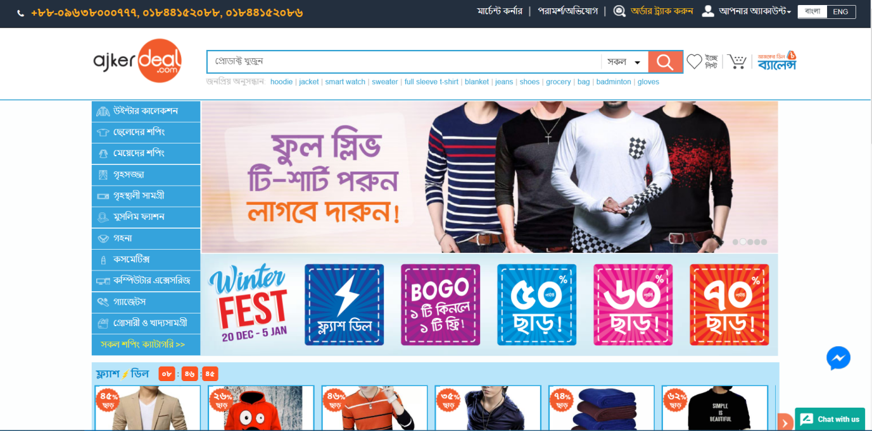

**Figure 2.3: Ajkerdeal online shopping**

**Chapter 3: Project Design**

Cloth Store is a virtual store on the Internet The selected items may be collected in a shopping cart. At checkout time, the items in the shopping cart will be presented as an order. At that time, more information will be needed to complete the transaction. Usually, the customer will be asked to fill or select a billing address, a shipping address, a shipping option, and payment information such as Bkash.

**3.1 Description**

Database is an organized collection of data. It is the collection of schemas, tables, queries, reports, views, and other objects. The data are typically organized to model aspects of reality in a way that supports processes requiring information, such as modelling the availability of rooms in hotels in a way that supports finding a hotel with vacancies.

* Any member can register and view available products.
* Only registered member can purchase multiple products regardless of quantity
* There are three roles available: Visitor, User and Organization.
* Visitor can view available products.
* User can view and purchase products.
* An Organizational store has some extra privilege including all privilege of visitor and user.
* Organization can add products, edit product information and add/remove product.
* Organization can add user, edit user information and can remove user
* Organization can ship order to user based on order placed by sending confirmation mail.

**3.2 Web Pages details**

A web page (US spelling webpage or Web page) is a document that is suitable for the World Wide Web and web browsers. The web page is what displays, but the term also refers to a computer file, usually written in HTML or comparable markup language. Web browsers coordinate the various web resource elements for the written web page, such as style sheets, scripts, and images, to present the web page.

* Home Page
* Product Page
* Organization Page
* Login Page
* Register Page

**3.3 Data Model**

A data model is a conceptual representation of the data structures that are required by a database. The first step in designing a database is to develop an Entity-Relation Diagram (ERD). The ERD serves as a blue print from which a relational database maybe deduced. Figure 1 shows the ERD for the project and later we will show the transformation from ERD to the Relational model.

**3.3.1 Entity Relationship Diagram**

An entity-relationship model (ER model) describes inter-related things of interest in a specific domain of knowledge. An ER model is composed of entity types (which classify the things of interest) and specifies relationships that can exist between instances of those entity types. In software engineering an ER model is commonly formed to represent things that a business needs to remember in order to perform business processes. Consequently, the ER model becomes an abstract data model that defines a data or information structure that can be implemented in a database, typically a relational database. In this **figure 3.1** show ER model about my project.

**Description of ER Diagram**

**User:** In this Diagram User is database table. Where four attribute .This is define the user identity and information.

* user Id: User Id is an attribute which is the primary key of the User table.
* f_name: Another attribute of table which define the name of user last name.
* l_name: Another attribute of table which define the name of user last name.
* email: Another attribute of table which define user email address.
* password: Another attribute of table which define user password.
* mobile: Another attribute of table which define user mobile no.
* address1: Another attribute of table which define user address.
* address2: Another attribute of table which define user address.

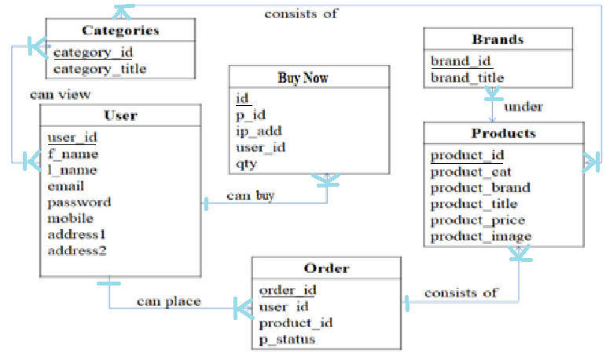

**Figure 3.1: Entity Relationship Diagram**

**Order:** When a user select a product than make a relation between Product table and User table thats call Order relation which is the verb. There are four attribute.

* product_id: Is foreign key and comes from the Product table. This attribute control the product which ordered by any customer.
* user_id: Is another primary key of Order Entity. Which is another foreign key of the table which maintain the customer from the customer table.
* order_id: Is a attribute which maintain the sequence of order number. One customer have one or more order.
* p_status: Is a attribute which define deliver status.

**Products:** In the database products table which store information about the product which make a relation between User table by the order .There are six attribute.

* product_id: Is foreign key and comes from the Product table This attribute control the product which ordered by any customer.
* product_cat: Is primary key and comes from the Product table This attribute control the product category.
* product_brand: Is attribute and defines the product brand.
* product_title: Is attribute and defines the product name.
* product_brand: Is attribute and defines the product brand.
* product_price: Is attribute which define and store the information price of product.
* product_image: Another Attribute of Products Table .Which store the product picture.

**3.3.2 Database Design**

Database design is the process of producing a detailed data model of database. This data model contains all the needed logical and physical design choices and physical storage parameters needed to generate a design in a data definition language, which can then be used to create a database. A fully attributed data model contains detailed attributes for each entity. The term database design can be used to describe many different parts of the design of an overall database system. Principally, and most correctly, i can be thought of as the logical design of the base data structures used to store the data. In the relational model these are the tables and views. In an object database the entities and relationships map directly be used to apply to the overall process of designing, not just the base data structure but also the forms and queries used as part of the overall database application within the database management system (DBMS).

**User_Info:**

The user_info table contains a list of all customers. The user_info table is referred to in the payment and rental tables and refers to the address and store tables using fore. The term database design can be used to describe many different parts of the design of an overall database system. Principally, and most correctly, it can be thought of as the logical design of the base data structures used to store the data.In the **table 3.1** shows about my project User_info table.

**Table 3.1: User_info Table**

|  |  |  |  |
| --- | --- | --- | --- |
| **SNO** | **NAME** | **TYPE** | **DESCRIPTION** |
| 1 | user_id | int | Primary Key |
| 2 | f_name | varchar |  |
| 3 | l_name | varchar |  |
| 4 | email | varchar |  |
| 5 | password | varchar |  |
| 6 | mobile | varchar |  |
| 7 | address1 | varchar |  |
| 8 | dddress2 | varchar |  |

**Description Of User_info Table:** User_info Table which store the information of customer. Who are purches the product. There are one primary key.

* user Id: User ld is an attribute which is the primary key of the User table.
* f_name: Another attribute of table which define the name of user last name.
* l_name: Another attribute of table which define the name of user last name.
* email: Another attribute of table which define user email address.
* password: Another attribute of table which define user password.
* mobile: Another attribute of table which define user mobile no.
* address1: Another attribute of table which define user address.
* address2: Another attribute of table which define user address.

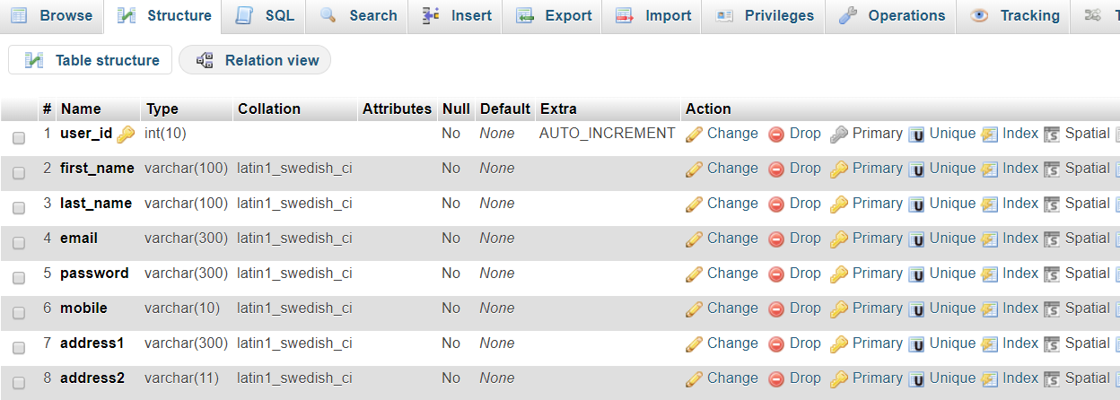

**Figure 3.2: User_Info Table from Database**

**Order:**

Orders belong in one table because the same kinds of information will be kept about each one. If ever you find yourself thinking you'd have multiple tables with the same structure, you should stop and think about your design .In **table 3.2** describe about order table.

**Table 3.2: Order Table**

|  |  |  |  |
| --- | --- | --- | --- |
| **SNO** | **NAME** | **TYPE** | **DESCRIPTION** |
| 1 | order_id | int | Primary Key |
| 2 | user_id | int |  |
| 3 | product_id | int |  |
| 4 | qty | int |  |
| 5 | trx_id | varchar |  |
| 6 | p_status | varchar |  |
| 7 | delivery_status | varchar |  |

**Description of Order Table:** When a user select a product than make a relation between Product.

* product_id: Is foreign key and comes from the Product table. This attribute control the product which ordered by any customer.
* user_id: Is the another primary key of Order Entity .Which is the another foreign key of the table which maintain the customer from the customer table.
* order_id: Is a attribute which maintain the sequence of order number One customer have one or more order.
* p_status: Is a attribute which define deliver status.

**Product:**

Table for each vendor and its products. This was my instinctive first choice, but I don't use most logical division: what's critical in determining the uniqueness of a products category, not which vendor it was purchased from. There will be category overlap if a vendor sells more than one kind of product. **table 3.3** describe my database product table.

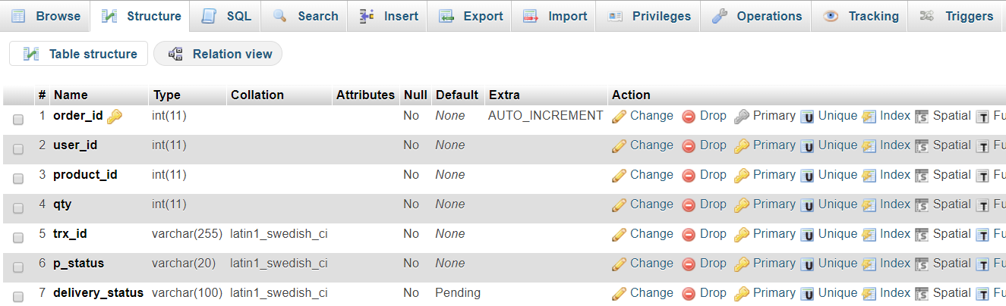

**Figure 3.3: Order Table from Database**

**Table 3.3: Product Table**

|  |  |  |  |
| --- | --- | --- | --- |
| **SNO** | **NAME** | **TYPE** | **DESCRIPTION** |
| 1 | product_id | int | Primary Key |
| 2 | product_cat | int |  |
| 3 | product_brand | int |  |
| 4 | Product_title | varchar |  |
| 5 | Product_price | int |  |
| 6 | Product_desc | text |  |
| 7 | Product_image | text |  |
| 8 | Product_keyword | text |  |

**Description of Product Table:**

* product_id: Is foreign key and comes from the Product table. This attribute control the product which ordered by any customer.
* product_cat: Is primary key and comes from the Product table. This attribute control the product category.
* product_brand: Is attribute and defines the product brand.
* product_title: Is attribute and defines the product name.
* product_brand: Is attribute and defines the product brand.
* product_price: Is Attribute which define and store the information price of product.
* product_image: Another Attribute of Products Table .Which store the product picture.

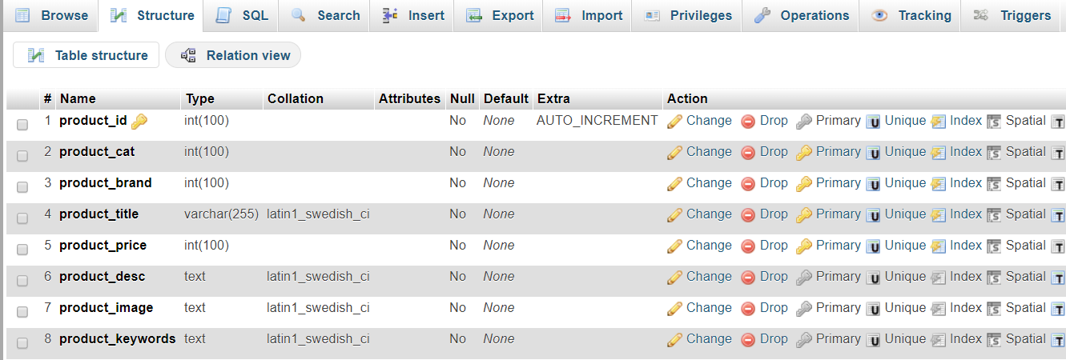

**Figure 3.4: Product from Database**

**3.4 Process Model:**

A Process Model tells us about how the data is processed and how the data flows from one table to another to gather the required information. This model consists of the Functional Decomposition Diagram and Data Flow Diagram.

**3.4.1 Data Flow Diagram (DFD)**

Data Flow Diagrams show the flow of data from external entities into the system, and from one process to another within the system. Data flow diagrams (DFDs) reveal relationships among and between the various components in a program or system. DFDs are an important technique for modeling a system's high-level detail by showing how input data is transformed to output results through a sequence of functional transformations. There are four symbols for drawing a DFD.

* Rectangles representing external entities, which are sources or destinations of data.
* Ellipses representing processes, which take data as input, validate and process it and output it.
* Arrows representing the data flows, which can either, be electronic data or physical items.
* Open-ended rectangles or a Disk symbol representing data stores, including electronic stores such as databases or XML files and physical stores such as filing cabinets or stacks of paper.
* Figures are the Data Flow Diagrams for the current system. Each process within the system is first shown as a Context Level DFD and later as a Detailed DFD. The Context Level DFD provides a conceptual view of the process and its surrounding input, output and data stores The Detailed the sub-processes within the system. In the **figure 3.5** describe about Data Flow Diagram.

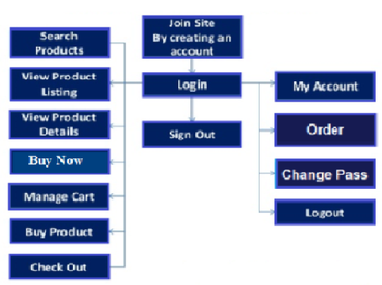

**Figure 3.5: Data Flow Diagram**

**Customer - Shopping Cart Context DFD**

Shopify provides a reliable, secure shopping cart solution for your ecommerce website. The shopping cart software allows you to accept credit cards and PayPal payments by integrating with over 70 payment gateways.A diagram giving an entire system's data flows and processing with a single Process (circle) is called a context diagram. A context diagram is expanded into a number of inter-related processes. Each process may be further expanded into aset of inter-connected sub processes. This procedure of expanding a DFD is known. In the **figure 3.6** describe about Customer Shoppingcart Context DFD.

**Customer-Authentication Context DFD**

Consumer authentication" is a blanket term to discuss the tools that are intended to validate that the authorized credit card holder is the one actually attempting to make a purchase. Visa calls their consumer authentication service "Verified by Visa," and MasterCard calls their service "MasterCard SecureCode." JCB International calls their service J/Secure while American Express only offers their service, SafeKey, in the UK and Singapore today. Key considerations when implementing or buying this functionality include. In the **figure 3.7** describe about Customer-Authentication Context DFD.

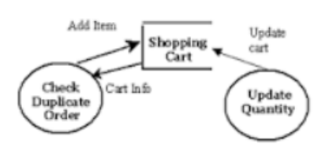

**Figure 3.6: Cart DFD**

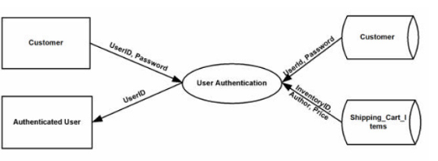

**Figure 3.7: Customer Authentication Context DFD**

**3.4.2 Use Case Diagram**

Web Customer actor uses some web site to make purchases online. Top level use cases are View items, Make Purchase and Client Register. View Items use case could be used by customer as top level use case if customer only wants to find and see some products. This use case could also be used as a part of Make Purchase use case. Client Register use case allows customer to register on the web site, for example to get some coupons or be invited to private sales. Notice, that Checkout use case Is included use case not available by itself - checkout is part of making purchase. Except for the Web Customer actor there are several other actors which will be described below with detailed use cases. In the **figure 3.8** describe about Use Case Diagram of my project.

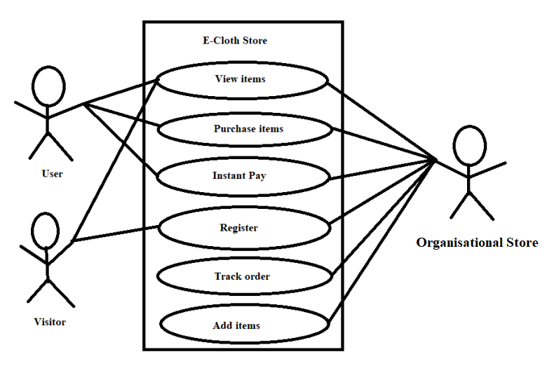

**Figure 3.8: Use Case Diagram**

**3.4.3 User Interface Design**

My application is user oriented. Here three types of user can view my website such as General user can only view the information Employer and user see same user interface but Organization can add remove view and update the content.

**Homepage:** The Home Screen will consist of screen were one can browse through the products which we have on our website. In the **figure 3.9** show home page of my project.

**Sign Up:** Visitor only can view the item instead of buying product. If he/she want to purchase a product he or she must have to register first. When a user want to need registration then click Sign Up button. In the **figure 3.10** describe about how can do registration of my project.

**Add Products:** Organization can add product to this website. Every product will show in home page. **Figure 3.11** shows home page.

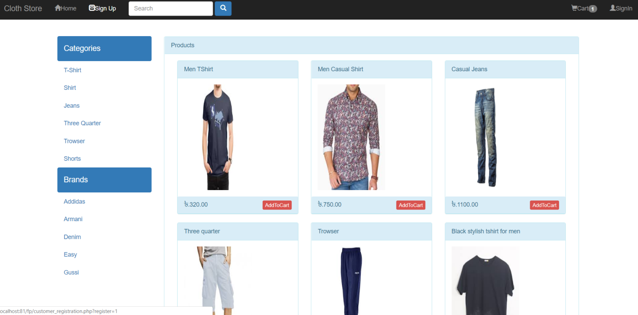

**Figure 3.9: Home Page**

**Edit/Delete Product:** Organization only can delete product. **Figure 3.12** describes the scenario. Click on delete button product will delete.

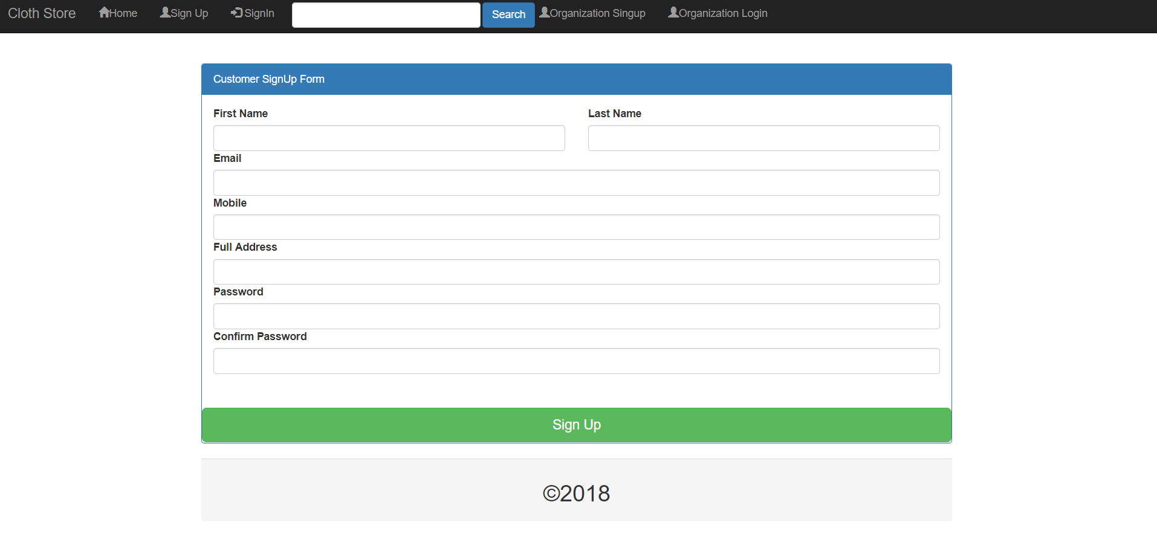

**Figure 3.10: Customer SignUp Form**

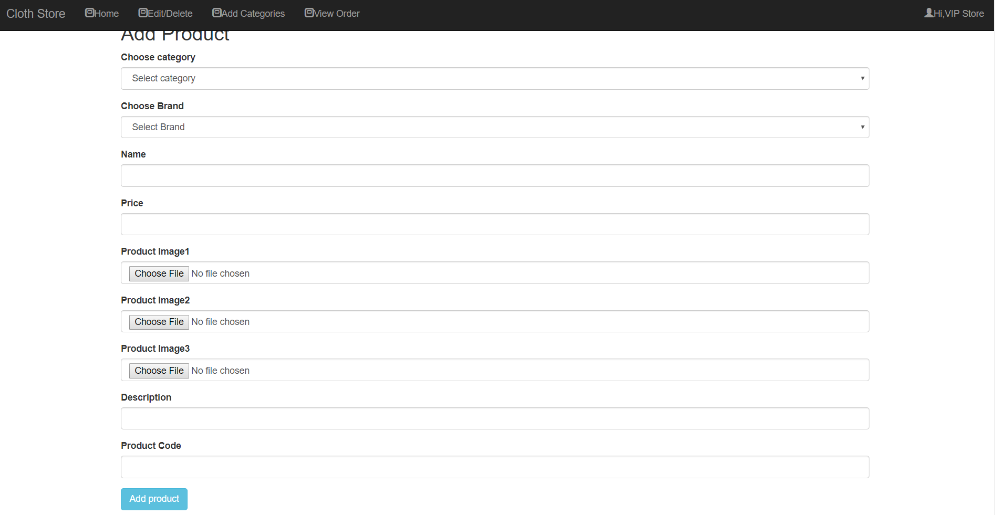 **Figure 3.11: Add Product**

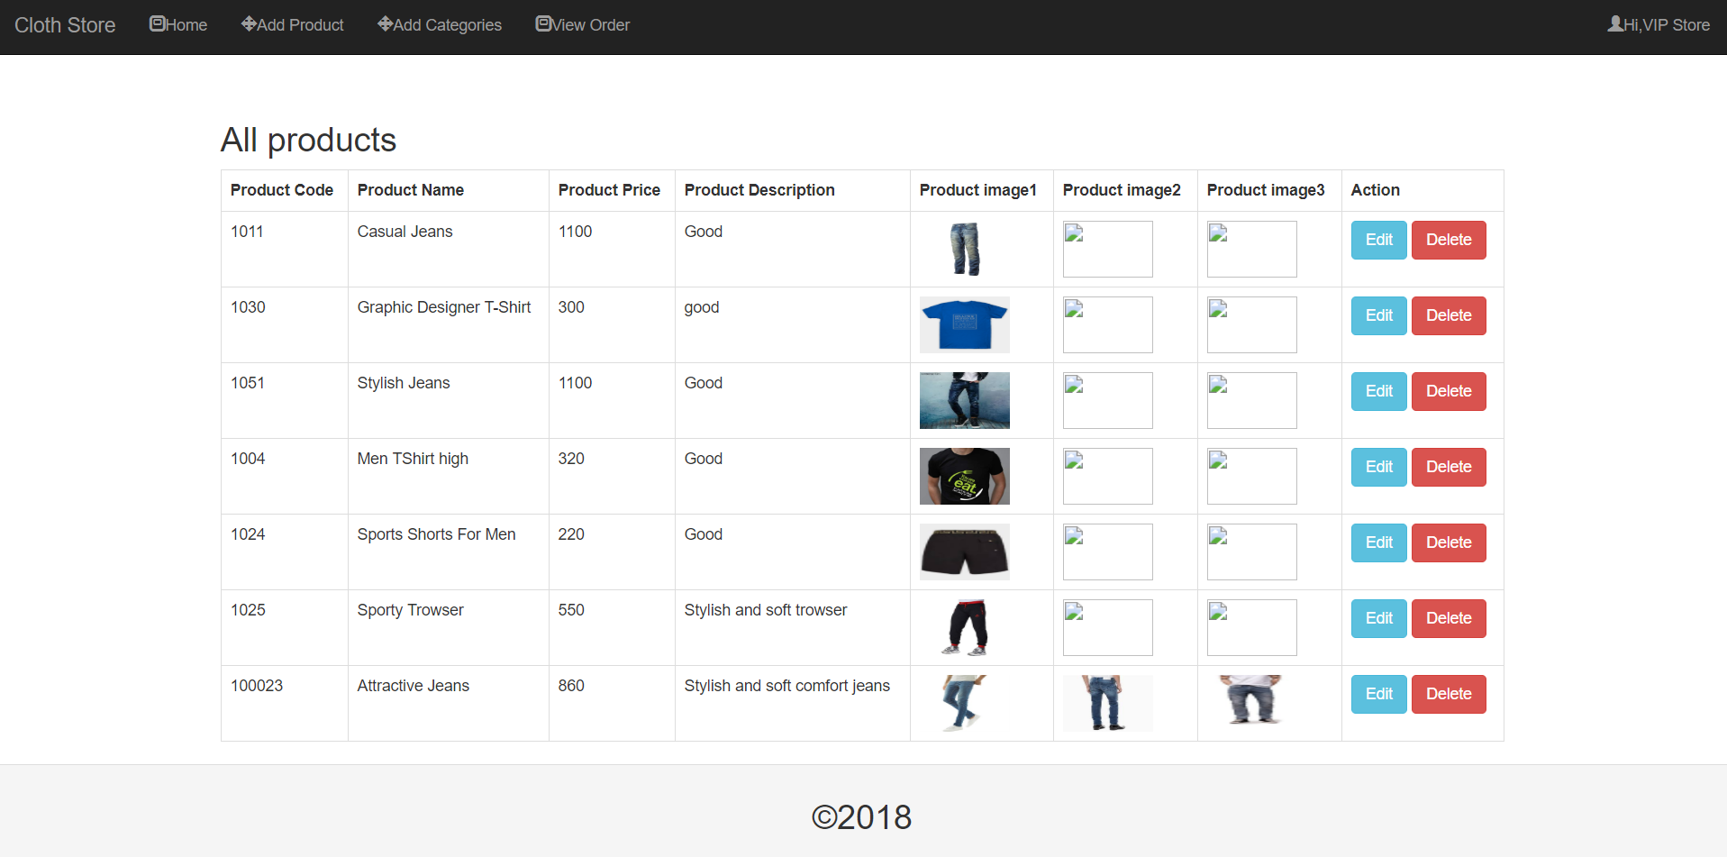

**Figure 3.12: Edit/ Delete Product**

**Chapter 4: Implementation Detail**

E-commerce essentially means selling products and services online -but it's not as simple as it may sound. E-commerce requires a sophisticated content management system and a s combines many separate elements. To begin with, e-commerce demands dedicated purchase, payment, and support systems along with customer relationship management procedures. A quality marketing effort is paramount. Underpinning it all is a quality Web site that needs professional development and attentive management. In implementing e-commerce, keep in mind.

* E-commerce is not suitable for every product and service.
* The best strategy is a "clicks-and-mortar" approach that combines online capabilities with more traditional retail resources.
* E-commerce is complex, and getting it right is expensive. Don't underestimate the difficulty of designing and managing an efficient e-commerce Web site.

**4.1 Organization side**

Organization panel category Web Template built upon HTML5, CSS and Bootstrap framework. This vibrant and versatile Organization template surely makes the top-of-list in its category with the cleverly coded and visually magnificent nature, and it has plethora of makes it a stand-out choice. The transformable navigation bar fetches the beauty and the header has the elements that are handy. This page is used for Organizationistrator login. Using valid username password Organizationistrator control all the reserving system such as add buss and routes. And update and delete the information data of the system.

**4.1.1 Create Username & Password**

The main username of your account cannot be changed, but you can change the password of the main user and create multiple users for your account.

* Storing valid username and password in database.

**4.1.2 Delete items**

Sometimes you might want to duplicate a product that you've created rather than entering all of the details again. This can save your time, as you'll only need to update the product name and any other variant or a product, then it is removed completely from your details that are different. If you delete a store Deleted products cannot be restored.

**4.1.3 Modify items**

To modify a prod modify, you must perform following .Get the instance of the product you want to modify. You must get the master version of the product and modify it.

* It will find the products table going to edit.php page.
* If valid information match then item can be modified.

**4.2 Customer side**

Customers may not always be right, but they always deserve a timely response queries Production possible with current production equipment at customer design encompasses many different skills and disciplines in the production. The term web design is we normally used to describe the design process relating to the front-end (client side) design of a website including writing mark up.

**4.2.1 Categories are selected**

Online shopping is a form of electronic commerce which allows consumers to directly buy goods or services from a seller over the Internet using a web browser. Consumers find a product of interest by visiting the website of the retailer among the pioneering retail categories which fueled the growth of online shopping.

**4.2.2 Buy Items**

A by-product is a secondary product derived from a manufacturing process or chemical reaction. It is not the primary product or service being produced. Customer have to click addToCart then checkout his/her cart then they can pay through Bkash or Cash on delivery.

**4.2.3 View Cart**

When any customer view there shopping cart after payment. At the surface, an ecommerce shopping cart is really something that every beginning online merchant intuitively recognizes. For example, almost no one would consider opening an online store without having made a few purchases online themselves .When customer click on cart they will find a drop down menu and they can view their cart.

**4.2.4 Change Quantity (in View Cart page)**

When a customer bye a product At this moment he can not understand about the quantity of product So my project a customer can easily change there quantity of product in Cart page.

**4.2.5 Remove Items**

Sometime current item can not be interested for a customer because of when a see new update product. For this reason a customer can easily remove the item.

**4.3 Hardware Interface**

The web based application that I made need some software and hardware interface. Without this interface the application cannot run properly

* Processor: Pentium II dual core, core 13.
* Hard Disk : 40Gb RAM:256MB4.
* Processor clock speed: 700 MHz Clock Speed.

**4.4 Software Interface**

* Operating System :Windows 7/8/10 or Linux/Solaris.
* Programming Language: php.
* User Interface :HTML.CSS.
* Web Browser Internet Explorer ,Google Chrome.
* Database : my sql.

**4.5 Security**

* Pages of the website must be access in the way they were intended to be accessed. Included files shall not be accessed outside of their parent file.
* Organizationistrator can only perform Organizationistrative task on pages they are privileged to access .Customer will not be allowed to access the Organizationistrator pages.

**Chapter 5: Test Plan**

In this chapter, the testing of the site and procedure of testing is depicted. Visitors to this site looking for testing plans, checklists and guidance on how to prepare before testing my website

**5.1 Introduction**

This is aimed at identifying and correcting errors. The major objective of this activity is to ensure that the processing done by the application is correct and meets the objectives of the organization. Test plan aids in effective and systematic testing of the system and it aims at checking the errors of omission and commission that hinders the realization of the objectives. It takes the bottom up testing approach.

**5.2 Importance of testing**

* Testing is used to find program errors on the system.
* It is used to find undercover errors in a program through the use of defect testing.
* Testing is also used to uncover new types of errors associated with new inventions and technology.
* Testing aims at assuring quality by enforcing consistency and reliability .
* It is used for both validation and verification to develop a product that meets user requirement.

**5.3 Test Plan Strategies**

The importance of the test plan is to show how the system is to be tested and also gives precise procedures to be followed during the test plan. The test date is identified, what is being tested and the output as well as the actual input. Test plan is one of the standard documents that should be produced in most software engineering projects. If the project does not have any test plan this means that the software produced is of low quality. This may not be acceptable to the user since it will not satisfy their needs. The test plan should be written as soon as you have identified the requirements.

* Unit testing
* Integration testing

**5.3.1 Unit Testing**

In this type of testing, the smallest testable parts of the system ie units are individually tested and independently examined for correct functionality. This type of testing involves both the positive testing and negative testing. This is important so as to make sure that the system functions properly used both correctly and incorrectly. In this case, the forms in visual basic as well as the tables for the database will be tested individually to ensure that they are compatible. This also applies to operating system and the software applications.

**5.3.2 Integration testing**

There is where two or more related programs are tested. The test will involve two types of approaches i.e. the bottom-up approach that begins with the simplest task to the most complex part e g. from applicant information table to the database and top-down approach that tests the system from the complex task to the simplest unit of all.

**Chapter 6: Limitation and Discussion**

This application is web based application and it is my first web based application. With expecting a best web application there has some limitations. Online shopping has become a popular shopping method ever since the internet has declared a takeover. There are many individuals that are looking for other amazing alternatives shopping and online shipping is just the fix for that.

**6.1 Limitation**

I have tried my best effort to complete the project successfully but there are some limitations in my project and the limitations are following:

* The physical and photos of the gap is too big Net purchase only is seen pictures of goods, to really get your hands, you will feel and the objects are not the same as. This is not in the mall to buy the rest assured.
* Online shopping is just to see pictures and articles on the simple introduction, like clothes or shoes and the like, you can directly see the suitable for you, and if in the mall to buy, you can try it on, his body, immediately buy, not so much to consider, however, online.
* Online payment security: Can be peeping, stolen passwords. Online shopping is most worried about is that he needs to use a bank account, some friends of the computer there is pilfer date trojan, can cause some serious account loss occurs, so everyone in the shopping.

**6.2 Discussion**

Internet has become a major resource in modern business, thus electronic shopping has gained. The significance not only from the entrepreneur's but also from the customer's point of view. If the shop looks poor or like hundreds of other shops the customer is most likely to skip to the other site. Hence we have designed the project to provide the user with easy navigation, retrieval of data and necessary feedback as much as possible. In this project, the user is provided with an ecommerce web site that can be used to buy cloth from online.

**Chapter 7: Conclusion and Future Scopes**

A good shopping cart design must be accompanied with user-friendly shopping cart application logic. It should be convenient for the customer to view the contents of their cart and to be able to remove or add items to their cart. The shopping cart application described in this project provides a number of features that are designed to make the customer more comfortable.

**7.1 Conclusion**

This project helps in understanding the creation of an interactive web page and the technologies used to implement it. The design of the project which includes Data Model and Process Model illustrates how the database is built with different tables, how the data is accessed and processed from the tables. The building of the project has given me a precise knowledge about how

Despite the hardships encountered in the entire development process the system has developed enabling improvement in its efficiency and effectiveness.

Maintenance and usage of the system will be easy as the documentation and user manual of the system will be available to all users. Also there will scope for enhancement as this was considered during development.

**7.2 Future Scopes**

* I will make the website more attractive.
* I will add video review of product.
* I will add chat option thats why customer can chat with Organization.
* I will add more information about product.

**Reference**

[1] https://www.amazon.com

[2] <https://www.ebay.com>

[3] <https://www.daraz.com.bd>

[4] https://ajkerdeal.com

[5] [https://www.tutorialspoint.com/software](https://www.tutorialspoint.com/software?fbclid=IwAR0fIB98uqAxZInRjtm6wSCMYBR34QReNUYgBeWxJSRbILx7b9V_VTKbeHw) engineering/software engineering overview